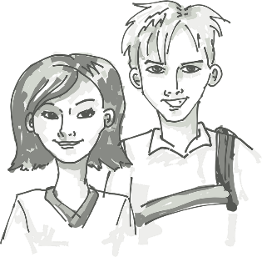
All About Me Alphabet Challenge
Can you come up with a word for each letter of the alphabet that says something about you?

A | N
B | O
C | P
D | Q
E | R
F | S
G | T
H | U
I | V
J | W
K | X
L | Y
M | Z

