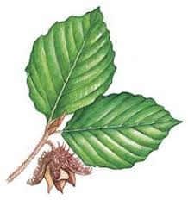
15 06 20
Hello everyone in Beech Class.
Here is your home learning for this week.

Maths:
This week, you will be practicing your measuring skills. You will also revise reading a thermometer and temperature. You will enjoy solving puzzles and using codes.

English.
This week, you will take a virtual tour of London! Using fact files, maps, and the internet, you will research information to write your own fact file. You will learn some facts about the Great Fire of London and how people used tube stations to shelter during World War Two. You will also read about the London Marathon.

Other Activities.
You will be making some paper models of London Landmarks and completeing some colouring activities. You will also be finding out about events that take place in London and designing your own London Marathon running costume.

Happy learning.

Best wishes from the Beech Class Learning Team.

