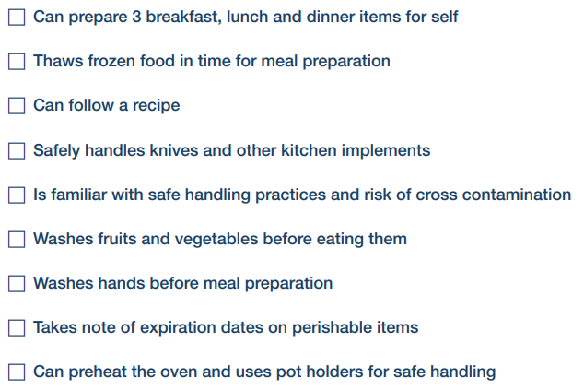
- Talk to an adult at home about each of these areas.
- Tick those you agree you can do confidently and independently.
- Think about which of these is something you might need to work on. If it is, then make it a target for one week and ask an adult at home to help support and monitor your progress.
- Put T and the date next to it. You can pick more than one if you like or focus on just one.
After a week How did you do? Pick one.
- I have got a little better but still need help.
- I have got better but still need to practise by myself.
- I can now do it independently and confidently.

Now review and decide which area you might need to work on next. Feel free to swap what you want to work on.

