Maths / Art/ Science
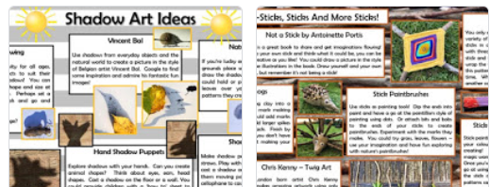
Number based activities could include:
Learning money through attention autism, this is lesson 1 - https://classroom.thenational.academy/lessons/to-encounter-and-explore-coins
Learning 2D shapes through attention autism, this is lesson 1 -
https://classroom.thenational.academy/lessons/2d-shape
Learning about 2D shapes and then 3D shapes in later lessons, this is lesson 1 -
https://classroom.thenational.academy/lessons/exploring-2d-shapes/activities/1
Science:
For a science activity
http://www.treetoolsforschools.org.uk/activities/pdfs/pdf_minibeast_hunt.pdf
A minibeast hunt is a great way to explore some of wonderful wildlife to be found in the UK!

