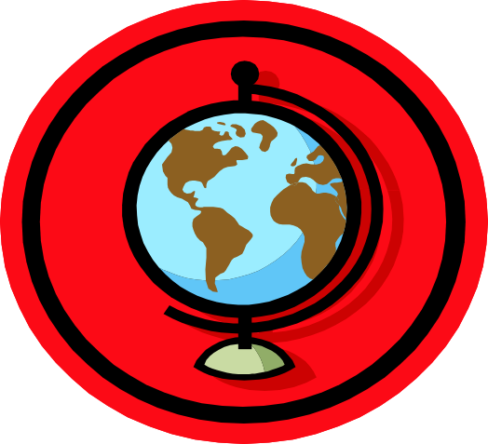
All Around the World

Can you name the seven continents of the world?

1) A………………,
2) A…………………….,
3) S…….…A………..,
4) N……….A…………….,
5) E……………………..,
6) A……………………..,
7) O………………………,

Can you name a country in each continent?
A country in A…………………. is………………………
A country in A…………………. is………………………
A country in N…………A…………..is……………………
A country in S………A……………. is…………………..
A country in E…………………. is………………………
A country in A…………………. is………………………
A country in O………………. is………………………

Can you name the five oceans of the world?
P……..…., A………….., A………….., I……………, S………...

