Hello all,
I hope you are all well?

Please use the Oak National resources (online) to support further learning opportunities https://www.thenational.academy/
Keep well, Keep safe.
Mr Dowling and Ms Vincent

Week 3
The farmer in the dell.
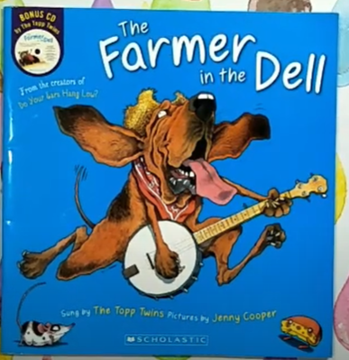 https://www.youtube.com/watch?v=G2C4opZmNG0
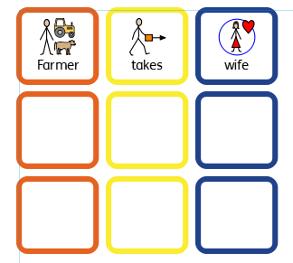
Use the colourful semantic grid to make your sentences.
What is the story about?
What does the Farmer take?
What does the Wife take?
What does the Child take?
What does the Nurse take?
What does the Cow take?
What does the Dog take?
What does the Cat take?
What does the Mouse take?
How does the cheese stand?
Week 4:
Mrs Wishy Washy’s farm.
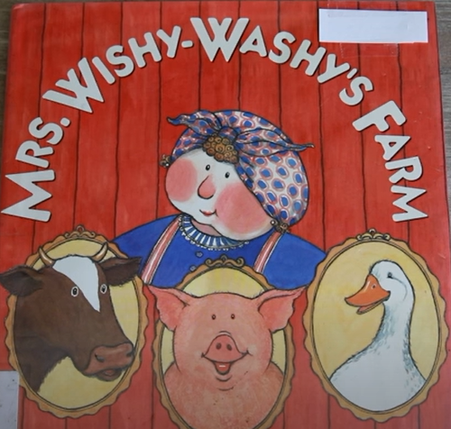 https://www.youtube.com/watch?v=cizS3vyV8ks
Week 5:
Driving my tractor
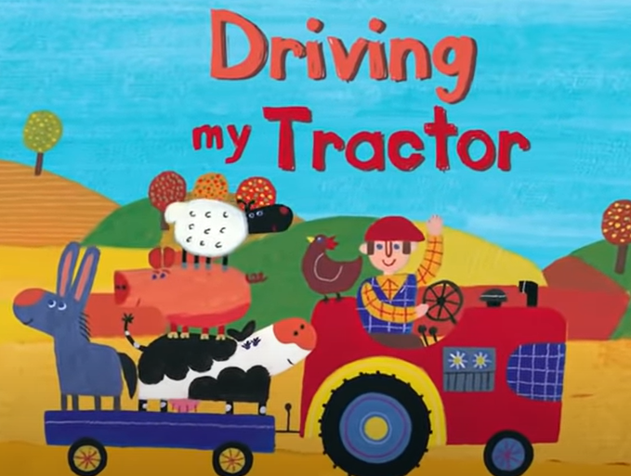 https://www.youtube.com/watch?v=Lj_odhwo81s

